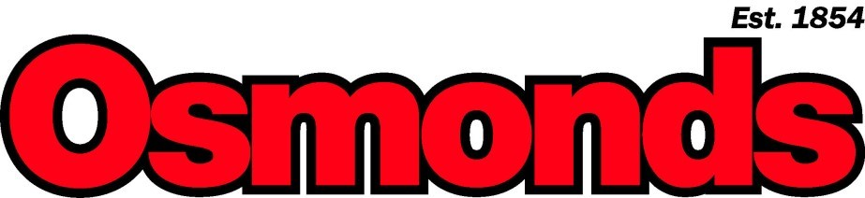 Boviboost
A premium, quality oral trace element and multivitamin supplement for cattle with the Omega 3 factor and Organic Chelates.
- Use at regular intervals to help ensure the animal has consistent levels of vitamins and trace elements, thus
- promoting optimum health and wellbeing, leading to increased performance.
- Formulated on an emulsified base, providing a fast and efficient route for administration and absorption
- Highly palatable and easily accepted.
- A Premium Range drench
Feeding Instructions  Heifers & Steers:  6 months 70ml  12 months 100ml  Cows at Drying Off: 100ml  Cows Returning to Service: 100ml  Difficult Calvers: 100ml  Calves:  At weaning 25ml  At 3 months 35ml  At 6 months 45ml  Embryo transplant donor cows:  100ml 3-4 weeks before and after flushing  Recipient cows:  100ml 3-4 weeks before and at implanting |  | Contains Vitamin A 10.8miu  Vitamin D3 1miu  Vitamin E 14500iu  Vitamin K 400mg  Vitamin B1 2500mg  Vitamin B2 1500mg  Folic Acid 1250mg  Pantothenic Acid 1200mg  Calcium 1900mg  Biotin 6mg  Vitamin B12 4.8mg  Cobalt 1500mg  Ascorbic Acid 1500mg  Iodine 10000mg  Nicotinamide 2500mg  Selenium 500mg  Vitamin B6 2000mg  Phosphorous 1000mg  Zinc 6300mg  Zinc MAAC 3375mg  Iron 840mg  Iron MAAC 360mg  Manganese 2250mg  Manganese MAAC 750mg  Copper 4500mg  Copper MAAC 4500mg  Omega 3 oils 150ml  Lysine 2000mg  Methionine 3000mg  Amino Acid Complex 1000mg
 | 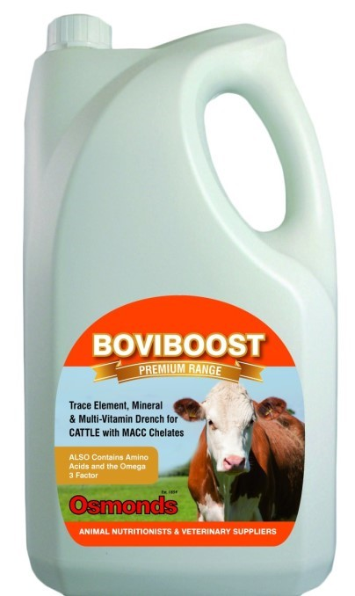
Bradeley Green Farm, Tarporley Road, Whitchurch, Shropshire, SY13 4HD Tel - 01948 668100 Fax - 01948 668101 info@osmonds.co.uk
WWW.OSMONDS.CO.UK

